Using Cloud Connect w/ QuantStudio 7 Pro

Online Quant Set Up
- Create a Cloud Connect account by clicking here and then hitting “Sign up now”.
- Once in your account, go to the Files page by clicking the  icon on the left bar.
- Create a new folder called “Templates” by clicking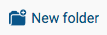 on the top right.
- Once in the newly created “Templates” folder, click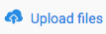 in the top right to upload the template files that we have provided by (they should end in a “.edt”)

Cloud Connect Homepage
This online page is where you can monitor the QuantStudio 7 Pro instrument online. It is where the templates to run experiments live, and also where the data files from experiments will be automatically uploaded to once they are done being run.

Running on Quant
- Following this video, login to the QuantStudio instrument with your Cloud Connect profile.
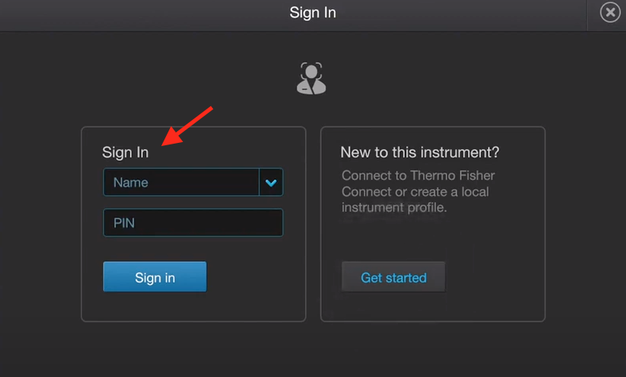

- Once logged in, click on the Open/Close icon on the top right to open the instrument’s door:
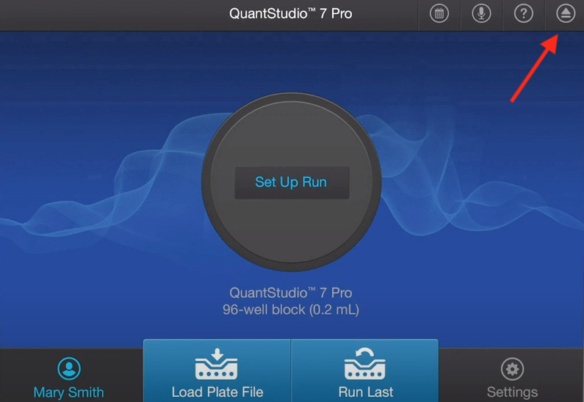
- Place PCR plate or PCR strips into the instrument, then click the Open/Close icon to shut the door.
- Click on “Set Up Run”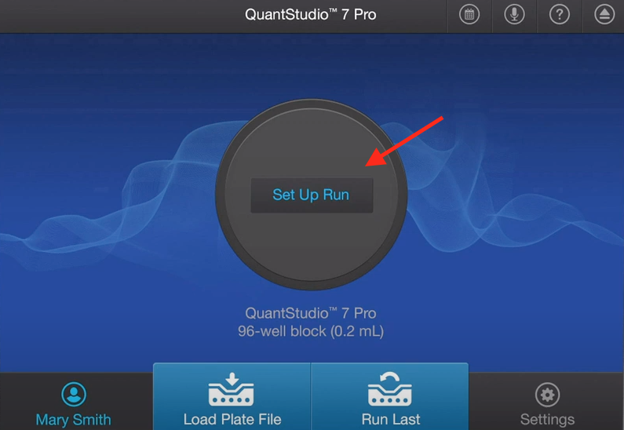

- Go to “Connect” tab on left

- Choose correct template for your run and click on it.
- Transfer the data to Cloud Connect by clicking on the Connect icon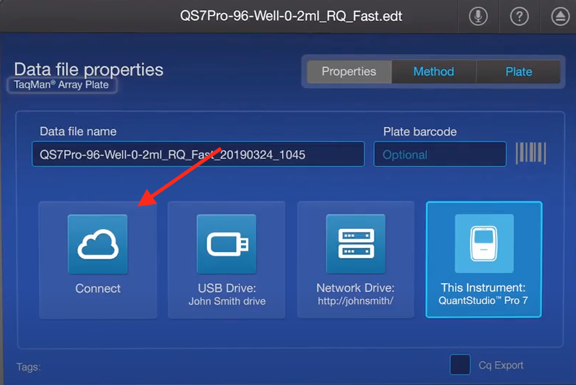

- Make sure your data is being sent to the correct folder (in this case it is going into “Personal Files/New File”):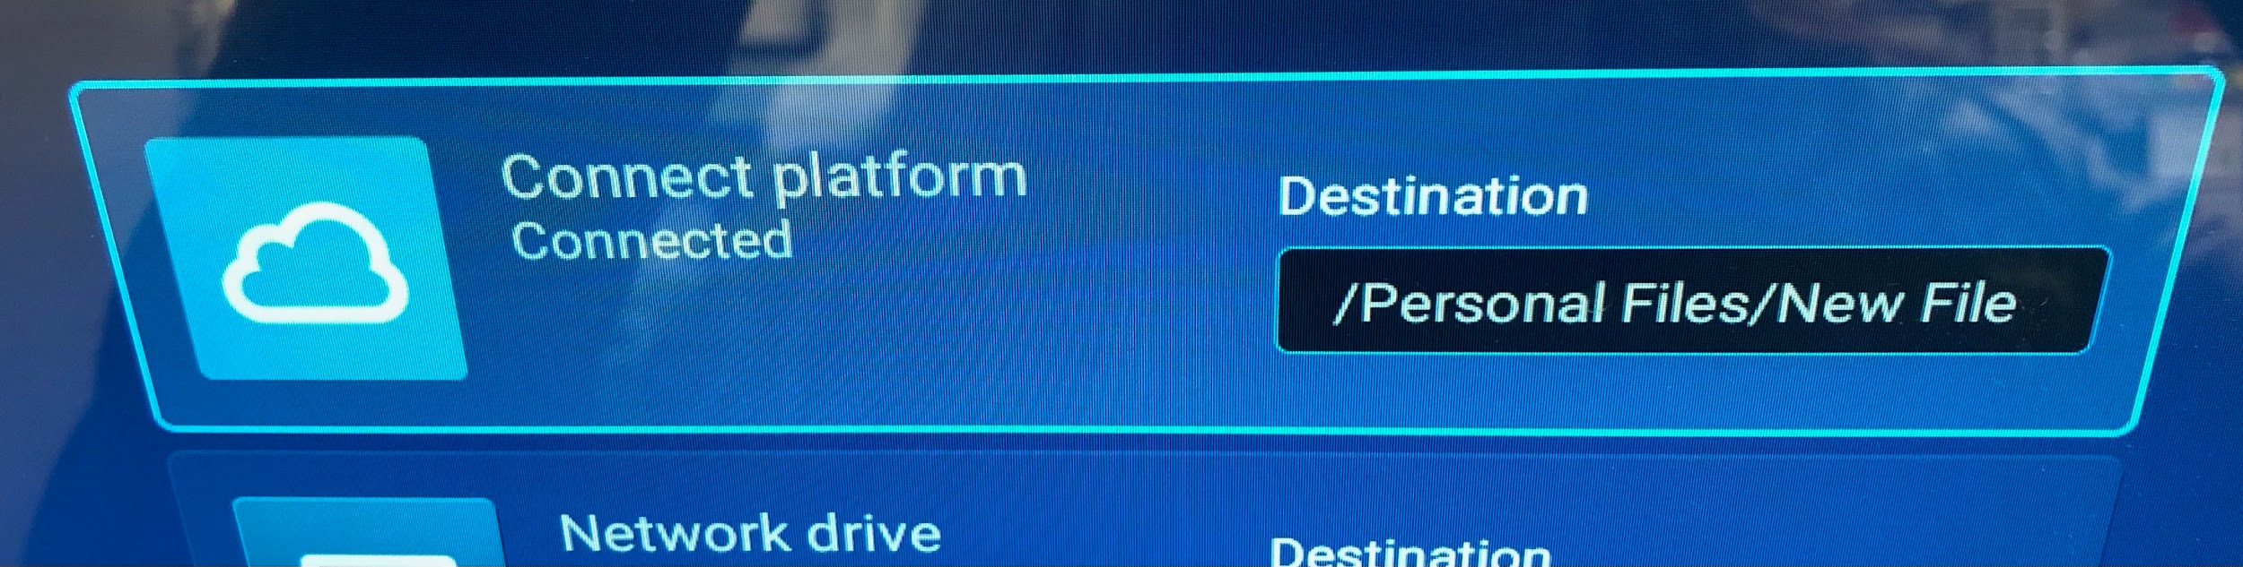
- Check your plate setup, and when you’re ready, click on “Start run”: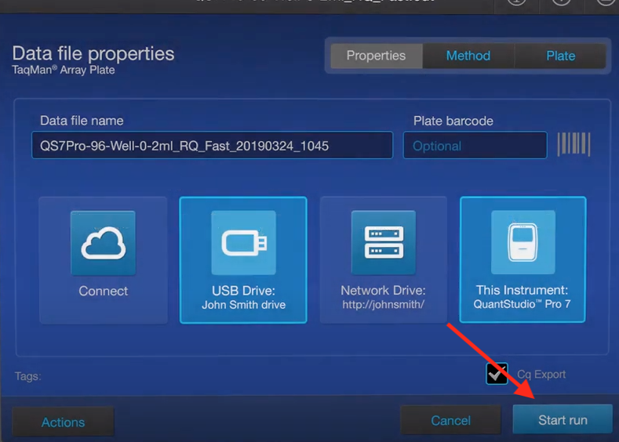

Get Uploaded Data
- Go to Cloud Connect and log in.
- Go to files and find the data that was previously uploaded from the Quant Studio 7 Pro.
- Download .xls file.
- To look at Ct curves, double-click on the .eds file.
- Under “Plate Setup” remove targets from all wells that were not used during the run.
- Hit “Analyze” and wait until there is a green check mark.
- Go to “Presence Absence” and look at the data.

Transfer Data
- Open “Quant Results Template”.
- Copy Sample placement from Run File to Template.
  - Make sure that the placement of the samples is the placement on the QuantStudio 7 Pro.
- Open .xls file previously downloaded from Cloud Connect.
- Copy data from columns “Well Position” to “Cq,” only copy data.
- Paste into Quant Results Template.
  - Check to see if it was pasted correctly.
- Copy “Well Position, Sample, FAM Ct and Cy5 Ct” columns from Template.
- Paste special (values only) into Run File.

